NAME | EMAN IBRAHIM ELSAED SHRIDA | PASSPORT NO. | A23236779
DATE OF BIRTH | 15/07/1989 | SEX | FEMALE
DATE COLLECTED | 11/10/2021 11.28 | LABORATORY ID | 100089
REPORT DATE | 14/10/2021
MOLECULAR BIOLOGY DEPARTMENT

COVID-19 RT_PCR TEST REPORT:
SPECIMEN

RESULT
NASOPHARYNGEAL SWAB
Negative

COMMENT :
Virus of COVID-19 fast spread across the world emphasized the need of most countries to respond properly to such a new virulent pathogen. SARS-COV2 (Severe acute respiratory syndrome corona virus 2, is responsible for COVID-19 disease , that was spread from Wuhan City of China to whole world. Since the reporting of full genome of COVID-19 by Chinese Center for Disease Control and Prevention, several target genes have been announced to screen and identify the COVID-19 infected cases. The method used in this test is TaqMan-based 1-step RT-qPCR assay. Limitations: 1-rare mutations within target regions may affect the primers and / or probe recognition sites and lead to PCR failure. 2-SARS COV2 detection depends on the number of copies present in the specimen, that may be affected by specimen collection methods, transport and/or storage , also patient factors, and /or stage of infection. 3-The assay analytical sensitivity is 10 copies/reaction, so any specimen with a result of not detected cannot be assumed to be negative. 4-Negative results don't preclude SARS COV2 infection and should not be used as the sole basis for treatment or patient management. -The collection of multiple specimens(type and time points for the same patient may be necessary to detect the virus. -The results of the test should be evaluated by a health care professional in the context of medical history, clinical symptoms and other diagnostic tests
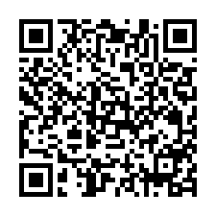

DR.KHALED SH. ABDELALEEM CONSULTANT OF MICROBIOLOGY LAB.

